钢结构计算书
Calculation Sheet for Steel Structure

浙江浙起机械有限公司
Zhejiang Zheqi Machinery Co., Ltd.
一、设计标准
I. Design Criteria
EN 13001-1: 2015 Cranes-General design - General principles and requirements
EN 13001-2: 2021 Crane safety - General design-Load actions
二、主梁的强度及刚性计算
II. Strength and Rigidity Calculation of the Girder
起重机的基本参数：
Basic parameters:
起重量：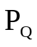=18t 跨度S=37.1m 起升高度H=30m 小车自重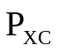=10.8t 起升速度Vq=50m/min
Lifting capacity: =18t; Span S=37.1m; Lifting height: H=30m; Trolley weight: =10.8t; Lifting speed: Vq=50m/min
1、受力分析
1. Force Analysis
作为室内用通用桥式起重机钢结构将承受小车自重（自重载荷）、（起升载荷）和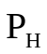（运行水平惯性载荷）三种基本载荷和偶然载荷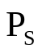，其主梁上将作用有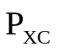、、载荷。
As a general-purpose overhead crane for indoor use, its steel structure is expected to bear three basic loads: the trolley weight (self-weight load), (lifted load) and (horizontal inertial load during operation), as well as accidental load , and the girder is expected to bear , , loads.
2、受力简图
2. Force Diagram
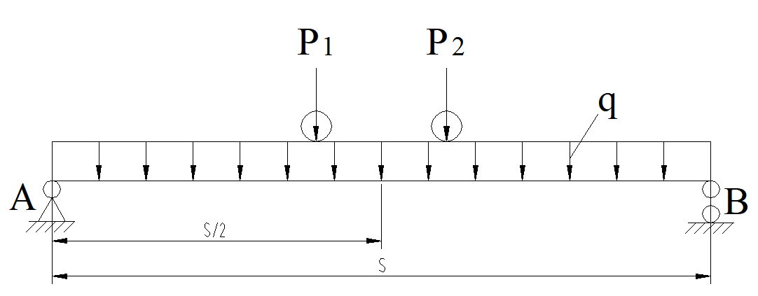
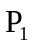与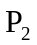为起重小车作用在一根主梁上的两个车轮轮压，由和小车自重分配到各车轮的作用力为轮压。如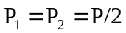时，可认为等于和小车自重之和的二分之一。
and are the two wheel pressures exerted by the trolley on a girder, which are the force distributed to each wheel by and the trolley weight. Provided, it can be assumed that is equal to half of the sum of and trolley weight.
主梁截面如图：
The girder section is as follows:
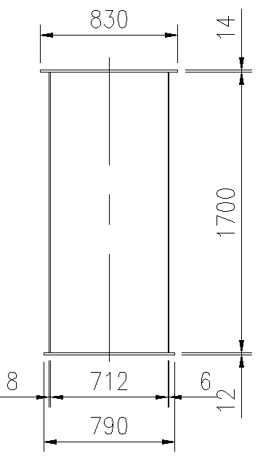
由主梁截面得出特性参数：
Characteristic parameters can be obtained from the girder section:
极惯性矩Ix=2.17*10¹⁰mm⁴ Iy=4.24*10⁹mm⁴
Polar moment of inertia: Ix=2.17*10¹⁰ mm⁴; Iy=4.24*10⁹ mm⁴
形心Yc=913.3mm Xc=387.4mm
Centroid: Yc=913.3mm Xc=387.4mm
主梁的抗弯模量Wx=Ix/Yc=2.376*10⁷mm³ Wy=Iy/Xc=1.094*10⁷mm³
Mending modulus of girder: Wx=Ix/Yc=2.376*10⁷ mm³; Wy=Iy/Xc=1.094*10⁷ mm³
主梁集中载荷q=3.9N/mm q_{H}=0.39N/mm
Concentrated load of girder: q=3.9N/mm q_{H}=0.39N/mm
3、主梁强度计算
3. Strength Calculation of Girder
当小车起吊额度起重量位于跨中时，主梁承受最大弯矩
When the lifting capacity of the trolley is at the mid span, the girder will bear the maximum bending moment
Mx=Pmax*S/4+qS2/8 My=P_{H}*S/4+q_{H}S2/8
Pmax = (∅2*+∅2min*)/2
∅2=∅2min+β₂Vq 起升机构工作级别M8，∅2min=1.2，β₂=0.68
∅2=∅2min+β₂Vq; Working class of lifting mechanism: M8, ∅2min=1.2, β₂=0.68
P_{H}=∅5m₂a P_{H}为小车运行时产生的水平惯性力 ∅5为机构加速动载系数
P_{H}=∅5m₂a; P_{H} is the horizontal inertial force generated during the trolley operation, while ∅5 is the dynamic factor for the acceleration of the mechanism
所以∅2=1.2+0.68*50/60=1.767
Thus, ∅2=1.2+0.68*50/60=1.767
Pmax= (1.767*18000+1.2*10.8) *9.8/2=2.194*10⁵N
P_{H}=1.2*28800*0.25=8640N
Mx=2.706*10⁹N.mm My=0.99*10⁸N.mm
此时主梁强度σw=Mx/Wx+My/Wy=123MPa
The strength of girder at this time: σw=Mx/Wx+My/Wy=123MPa
考虑到偏轨梁：σ≈1.15σw=141.45MPa
Whereas, bias-rail girder: σ≈1.15σw=141.45MPa
许用强度[σ]=σs/n=355/1.48=240MPa
Allowable strength: [σ]=σs/n=355/1.48=240MPa
因此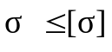强度满足要求！
Thus , the strength being satisfactory!
4、主梁刚度计算
4. Stiffness Calculation of Girder
（1）垂直静刚度
(1) Vertical static stiffness
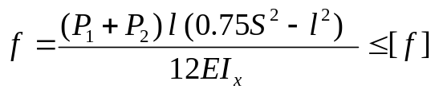
为小车轮压至主梁支承处距离，见下图所示。
refers to the distance from the trolley wheel pressure to the girder support, as shown below.
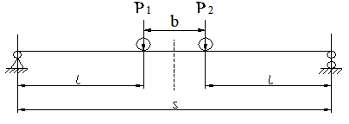
当时
When
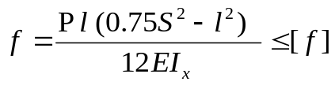
简化后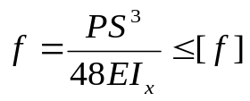
Simplified to be
其中：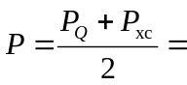（18000+10800）*9.8/2=1.4112*10⁵N
Where, (18000+10800) *9.8/2=1.4112*10⁵N
钢材的弹性模量E=2.06*10⁵N/mm²
Elasticity modulus of steel: E=2.06*10⁵ N/mm²
代入数据后算出主梁的刚度=33.6mm
The stiffness is calculated through putting the data into formula: =33.6mm
许用垂直刚度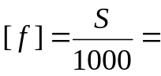37.1mm
Allowable vertical stiffness: 37.1mm
因此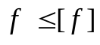垂直刚度满足要求！
Thus , the vertical stiffness being satisfactory!
（2）水平静刚度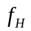
(2) Horizontal static stiffness
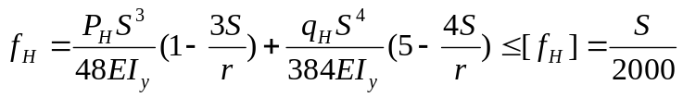
简化成简支梁后
After being simplified to a simply supported beam,
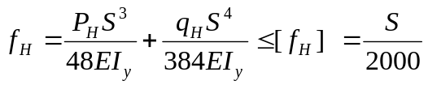
其中：
where:
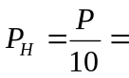1.4112*10⁴N
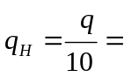0.39N/mm
代入数据后算出主梁的刚度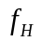=17.8mm
The stiffness is calculated through putting the data into formula: =17.8mm
许用水平刚度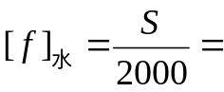18.55
Allowable horizontal stiffness: 18.55
因此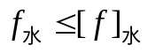 水平刚度满足要求！
Thus , the horizontal stiffness being satisfactory!
三、端梁的强度计算
III. Strength Calculation of End Beam
端梁截面如图：
The end beam section is as follows:
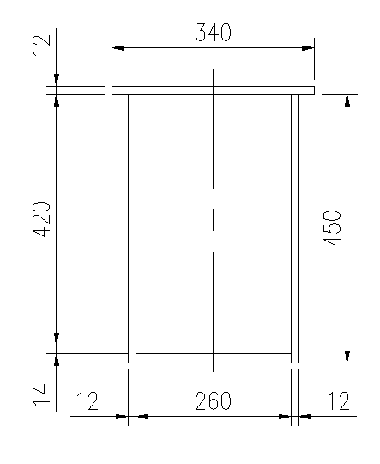
由主梁截面得出特性参数：
Characteristic parameters can be obtained from the girder section:
极惯性矩Ix=5.38*10⁸mm⁴ Iy=2.4*10⁸mm⁴
Polar moment of inertia: Ix=5.38*10⁸ mm⁴; Iy=2.4*10⁸ mm⁴
形心Yc=238.1mm Xc=170mm
Centroid: Yc=238.1mm; Xc=170mm
主梁的抗弯模量Wx=Ix/Yc=2.26*10⁶mm³ Wy=Iy/Xc=1.41*10⁶mm³
Mending modulus of girder: Wx=Ix/Yc=2.26*10⁶ mm³; Wy=Iy/Xc=1.41*10⁶ mm³
最大轮压P=1.36*10⁵N
Max. wheel pressure: P=1.36*10⁵N
水平惯性力P_{H}=∅5m_{G}a =1.2*74000*0.28=2.49*10⁴N
Horizontal inertial force: P_{H}=∅5m_{G}a =1.2*74000*0.28=2.49*10⁴N
Mv=P*C=1.36*10⁸N.mm
M_{H}=P_{H}*C=2.49*10⁷N.mm
C见端梁图，C=1000mm
See the end beam diagram for C, C=1000mm
此时端梁强度σ=Mv/Wx+M_{H}/Wy=78MPa
The end beam strength at this time: σ=Mv/Wx+M_{H}/Wy=78MPa
因此端梁的强度满足要求！
Thus, the end beam strength is satisfactory!
四、主、端梁连接螺栓计算
IV. Calculation for Bolts of Girder and End Beam
连接法兰板上的作用力F = 1.25（x/2 + y + z）
Force on the flange plate: F = 1.25 (x/2 + y + z)
x为主梁自身、走台及栏杆等的总重量 x=36000kg
x refers to the total weight of girder, platform and rail; x=36000kg
y为卷扬小车重量 y=10800kg
y is the weight of the winch trolley; y=10800kg
z为安全工作载荷 z=18000kg
z refers to the safe working load; z=18000kg
所以F=1.25 （18000 + 10800 + 18000）=58500kg =573.3 kN
Thus, F=1.25 (18000 + 10800 + 18000) =58500kg =573.3 kN
主梁与端梁连接螺栓规格：M24，小径是20.75mm，每根端梁的螺栓数量为16个
Spefication of bolts connecting the girder to the end beam: M24, minor diameter: 20.75mm, number of bolts for each end beam: 16
单个螺栓面积为 πd²/4 = .142*20.75*20.75/4 = 338 mm²
The area of a single bolt: πd²/4 = 3.142*20.75*20.75/4 = 338 mm²
螺栓总面积A=16*338 = 5408 mm²
Total area of bolts: A=16*338 = 5408 mm²
螺栓上的应力σ=/A=573300/5408= 106 N/mm²
Stress on the bolt: σ=F/A=573300/5408= 106 N/mm²
根据DIN 15018表12，配合螺栓的容许剪切应力为（0.8x168=134.4N/mm²），容许拉伸应力为140N/mm²。
According to Table 12 of DIN 15018, the allowable shear stress for bolts is (0.8×168=134.4N/mm²), and the allowable tensile stress is 140N/mm².
所以螺栓满足使用要求！
Thus, the bolt is satisfactory!
五、大车运行机构计算
V. Calculation of Crane Traveling Mechanism
1、大车车轮轴计算
1. Calculation of Wheel Axle
车轮直径400mm，运行速度70m/min，最大轮压Pmax=136kN，最小轮压Pmin=82kN，车轮计算轴径100mm，车轮材质42CrMo，车轮轴材质42CrMo，大车轨道面宽l=70mm，轨道选43kg/m。
Wheel diameter: 400mm, traveling speed: 70m/min, max. wheel pressure Pmax=136kN, min. wheel pressure Pmin=82kN, calculated axle diameter: 100mm, wheel material: 42CrMo, axle material: 42CrMo, track surface width l=70mm (the track: 43kg/m).
车轮的疲劳强度：Pmean=（Pmin+2Pmax）/3=118kN
Fatigue strength of wheel: Pmean= (Pmin+2Pmax) /3=118kN
车轮接触应力计算:
Calculation of wheel contact stress:
（1）线接触的允许轮压P_{L}=kDlC₁C₂=7.2*400*70*0.92*0.8=148.4kN
(1) Allowable wheel pressure for line contact: P_{L}=kDlC₁C₂=7.2*400*70*0.92*0.8=148.4kN
（2）点接触的允许轮压P_{p}=1.9kDl=1.9*7.2*400*70=383kN
(2) Allowable wheel pressure for point contact: P_{p}=1.9kDl=1.9*7.2*400*70=383kN
k为车轮的许用比压
k refers to the allowable specific pressure of wheel
Pmean＜P_{L}，线接触强度满足。
Pmean＜P_{L}, the line contact strength being satisfactory.
Pmax＜P_{p}，点接触强度满足。
Pmax＜P_{p}, the point contact strength being satisfactory.
车轮轴最危险处所受弯矩M=68000*888=5.984*10⁶N.mm
Bending moment at the most dangerous part of the wheel axle: M=68000*888=5.984*10⁶N.mm
弯曲应力σ=M/W=5.984*10⁶/（π100³/32） =61MPa
Bending stress: σ=M/W=5.984*10⁶/ (π100³/32) =61MPa
因此大车车轮轴满足要求！
Thus, the wheel axle of the crane is satisfactory!
六、小车运行机构计算
VI. Calculation of Trolley Traveling Mechanism
1、小车车轮轴计算
1. Calculation of Wheel Axle
车轮直径315mm，运行速度55m/min，最大轮压Pmax=81kN，最小轮压Pmin=45kN
Wheel diameter: 315mm, traveling speed: 55m/min, max. wheel pressure Pmax=81kN, min. wheel pressure Pmin=45kN
车轮计算轴径85mm，车轮材质42CrMo，车轮轴材质42CrMo，
Calculated axle diameter: 85mm, wheel material: 42CrMo, axle material: 42CrMo
小车轨道面宽l=70mm
Track surface width l=70mm
车轮的疲劳强度：Pmean=（Pmin+2Pmax）/3=69kN
Fatigue strength of wheel: Pmean= (Pmin+2Pmax) /3=69kN
车轮接触应力计算:
Calculation of wheel contact stress:
（1）线接触的允许轮压P_{L}=kDlC₁C₂=7.2*315*70*0.92*0.8=117kN
(1) Allowable wheel pressure for line contact: P_{L}=kDlC₁C₂=7.2*315*70*0.92*0.8=117kN
（2）点接触的允许轮压P_{p}=1.9kDl=1.9*7.2*315*70=301.6kN
(2) Allowable wheel pressure for point contact: P_{p}=1.9kDl=1.9*7.2*315*70=301.6kN
k为车轮的许用比压
k refers to the allowable specific pressure of wheel
Pmean＜P_{L}，线接触强度满足。
Pmean＜P_{L}, the line contact strength being satisfactory.
Pmax＜P_{p}，点接触强度满足。
Pmax＜P_{p}, the point contact strength being satisfactory.
车轮轴最危险处所受弯矩M=40500*62=2.51*10⁶N.mm
Bending moment at the most dangerous part of the wheel axle: M=40500*62=2.51*10⁶N.mm
弯曲应力σ=M/W=2.51*10⁶/（π85³/32） =41.67MPa
Bending stress: σ=M/W=2.51*10⁶/ (π85³/32) =41.67MPa
因此小车车轮轴满足要求！
Thus, the wheel axle of the trolley is satisfactory!

